MENG 4010 – INDUSTRIAL NETWORKING
Lab 03 Report – Communication Between Allen-Bradley PLCs Using Produced/Consumed Tags

Item | Details
Student | Michael McCorkell (N01500049)
Course | MENG 4010 – Industrial Networking
Lab Date | October 1st, 2026
Devices | Two Allen-Bradley ControlLogix 1756-L81E PLCs: Station_212 (10.116.254.212, producer) and Station_214 (10.116.254.214, consumer), each with a 1756-IF8 analog input module
Software / tools | Studio 5000 Logix Designer, RSLinx/RSWho, Windows Command Prompt (ping)

Instructor’s Confirmation
The course instructor’s signature below verifies completion of the lab demonstration.
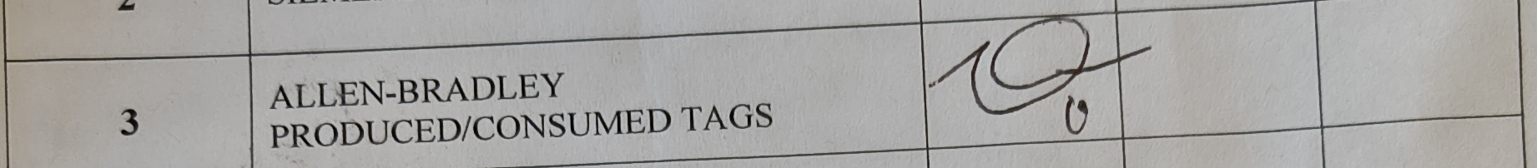

1. Assignment Summary

1.1 Objectives
This lab set up real-time data exchange between two ControlLogix 1756-L81E controllers using Rockwell’s produced/consumed tag mechanism over EtherNet/IP. By the end of the lab the goal was to be able to:
- Configure a produced tag in one controller and a matching consumed tag in a second controller.
- Read an analog input (0–10 V) and share it between controllers over Ethernet without explicit MSG instructions.
- Convert the raw analog count into an engineering value (volts).
- Verify the inter-PLC link using online tag/program monitoring in Studio 5000.

1.2 Work Completed
Station_212 (10.116.254.212) was configured as the producer: it reads analog input channel 0 of its 1756-IF8 module and scales the raw count to a floating-point voltage, which is produced on the tag Input_Voltage. Station_214 (10.116.254.214) was configured as the consumer: it receives that value on a consumed tag (shown in the program as Input_Voltage_Read) and writes it to a local tag, Input_Voltage_212, for monitoring. Both controllers were confirmed reachable on the network, browsed in RSWho, and brought online in Studio 5000; the ladder logic on each was then monitored live to confirm the value transferred correctly and tracked a changing input voltage in real time.

1.3 Conclusions
The produced/consumed tag connection worked as intended: the value read and scaled on Station_212 appeared on Station_214 within one scan after the connection was established, and it continued to track the live analog input as the voltage was changed at the source (Figures 10–11). This confirms that produced/consumed tags give two controllers a standing, cyclic data link over EtherNet/IP without either program needing to call an explicit MSG instruction, once the tag types, data types and connection are correctly matched between the two controllers.

2. PLC Program Documentation

2.1 Network Verification
Before configuring the tags, both controllers were confirmed reachable on the 10.116.254.0/24 subnet with ping, then browsed together in RSWho so that both backplanes and I/O modules were visible from one workstation.
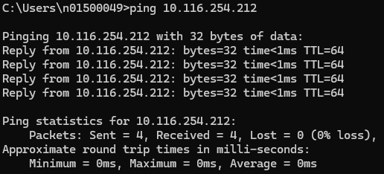  Figure 1 – Ping to 10.116.254.212 (Station_212): replies received | 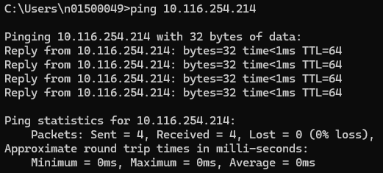  Figure 2 – Ping to 10.116.254.214 (Station_214): replies received
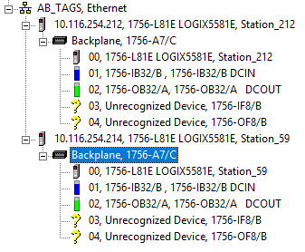
Figure 3 – RSWho: both controllers visible on AB_TAGS, Ethernet — 10.116.254.212 (Station_212) and 10.116.254.214, each with its 1756-IB32/B, 1756-OB32/A, and (unrecognized) 1756-IF8/1756-OF8 modules on the backplane

2.2 Controller Project Trees and I/O Configuration
Each controller’s project tree was opened online to confirm its I/O configuration included a 1756-IF8 analog input module, and that the Ethernet branch listed the other controller’s path — confirming the two were set up to talk to each other.
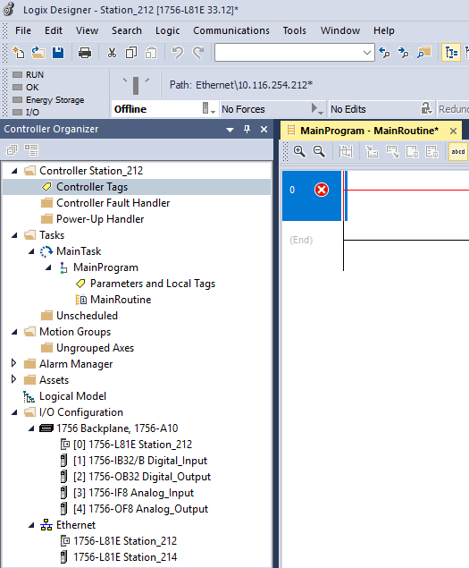  Figure 4 – Station_212 project tree (path Ethernet\10.116.254.212): I/O Configuration lists the 1756-IF8 Analog_Input and 1756-OF8 Analog_Output modules; Ethernet branch lists both Station_212 and Station_214 | 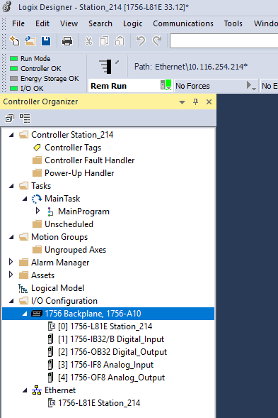  Figure 5 – Station_214 project tree (path Ethernet\10.116.254.214, Controller OK, Rem Run): matching 1756-IF8/1756-OF8 modules on its own backplane

2.3 Produced Tag Configuration (Station_212)
The produced tag was created in Station_212’s controller tag database: name Input_Voltage, Type Produced, Data Type REAL (Float style), scope Station_212, external access Read/Write.
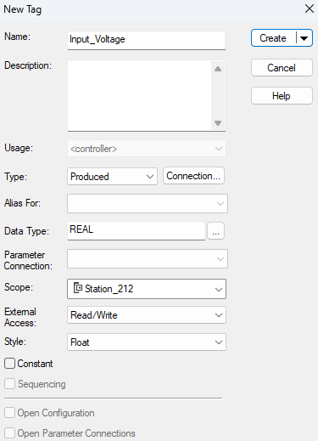
Figure 6 – New Tag dialog in Station_212: Input_Voltage, Type = Produced, Data Type = REAL, Scope = Station_212

2.4 Station_212 Ladder Logic — Analog Read and Scaling
MainRoutine on Station_212 uses a free-running TON timer (MM_Timer, preset 100) as a scan-rate reference, and a CPT (Compute) instruction that scales the raw analog count from the 1756-IF8 module to a 0–10 V floating-point value: Input_Voltage = Local:3:I.Ch0Data / 32767 * 10. With the analog input at full scale, Input_Voltage reads 10.0, as shown in both captures below (taken a short time apart — note the differing timer accumulator values, confirming the program was running online, not just displayed statically).
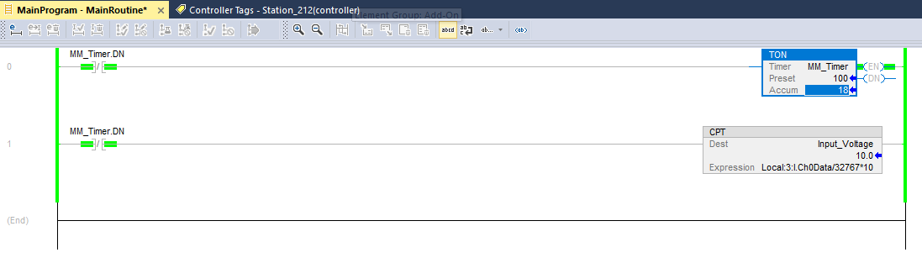  Figure 7 – Station_212 online, MM_Timer.Accum = 18: Input_Voltage = Local:3:I.Ch0Data/32767*10 = 10.0 | 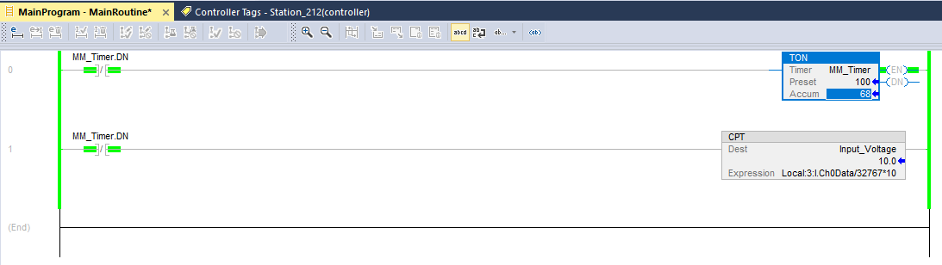  Figure 8 – Station_212 online, MM_Timer.Accum = 68 (later scan): Input_Voltage still 10.0, confirming a steady input

2.5 Station_214 Ladder Logic — Consumed Tag and Transfer
MainRoutine on Station_214 uses the same TON timer pattern, followed by a MOV instruction that copies the consumed value, Input_Voltage_Read (the local alias for Station_212’s produced tag), into a local monitoring tag, Input_Voltage_212. In this first capture the controller was still offline, so the destination value shows “??” and the rung carries an unevaluated/error marker.
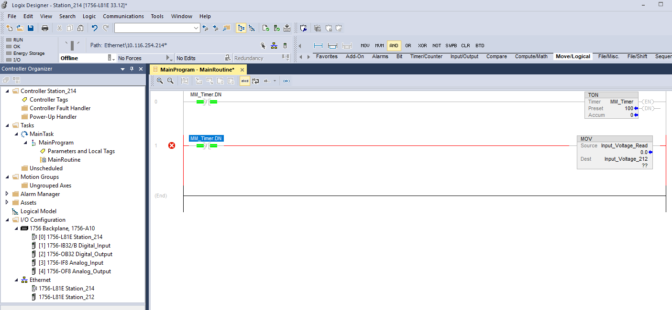
Figure 9 – Station_214 offline: MOV Source = Input_Voltage_Read (0.0), Dest = Input_Voltage_212 (??, not yet evaluated)

2.6 Verified Data Transfer (Both Controllers Online)
With both controllers online, Station_212’s produced value and Station_214’s consumed/moved value were monitored side by side. At full-scale input both read 10.0 V (Figure 10). The input voltage was then changed at the source, and both controllers were re-captured a moment later: Station_212 computed 4.2280345 V while Station_214 had already received and stored 4.1920223 V — the small difference reflects the one-scan lag between the producer updating the tag and the consumer’s next read, which is expected for a cyclic connection rather than an instantaneous one.
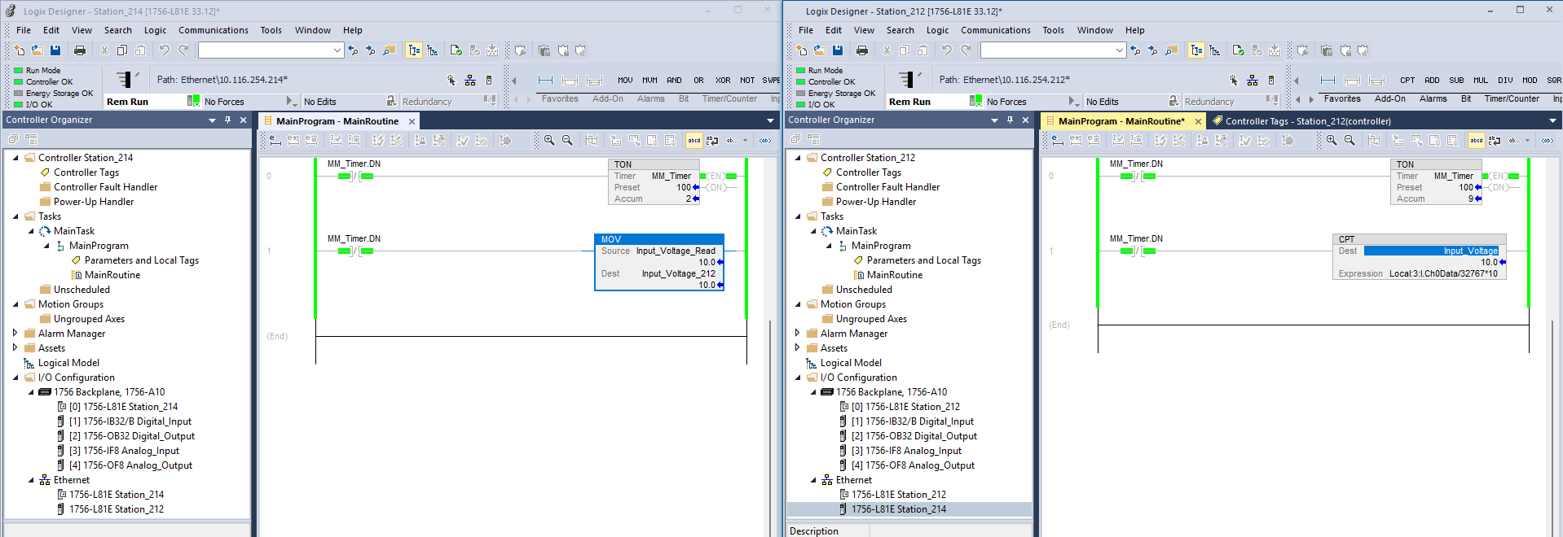
Figure 10 – Both controllers online at full-scale input: Station_212 CPT Input_Voltage = 10.0 (right) matches Station_214 MOV Input_Voltage_Read → Input_Voltage_212 = 10.0 (left)
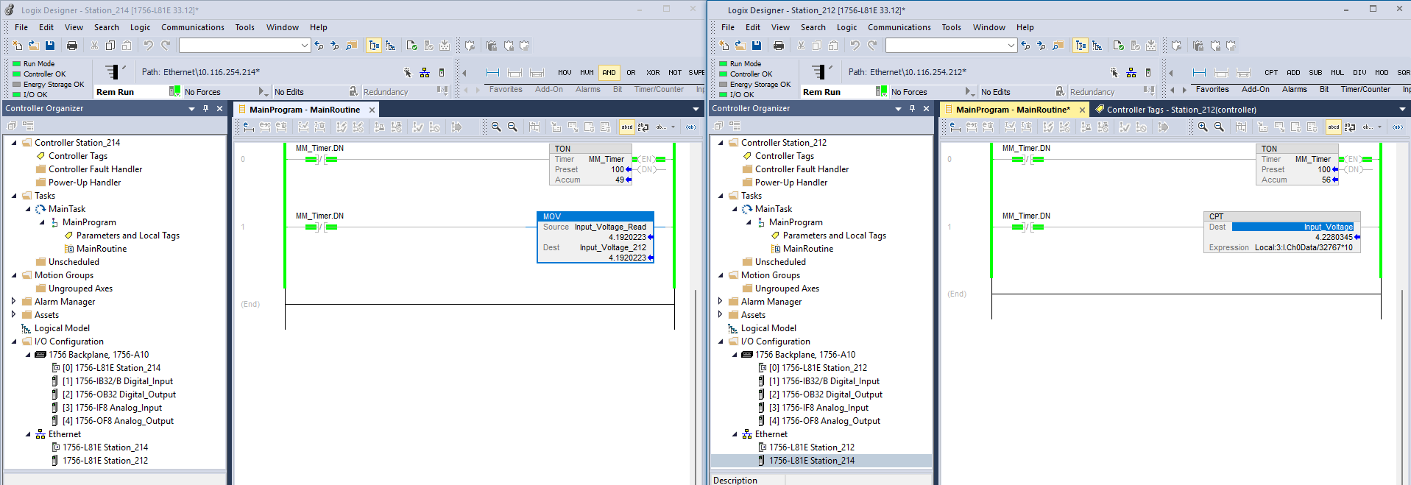
Figure 11 – Both controllers online after changing the input voltage: Station_212 Input_Voltage = 4.2280345 V (right) vs Station_214 Input_Voltage_212 = 4.1920223 V (left) — real-time tracking with a one-scan lag

2.7 Application Photo
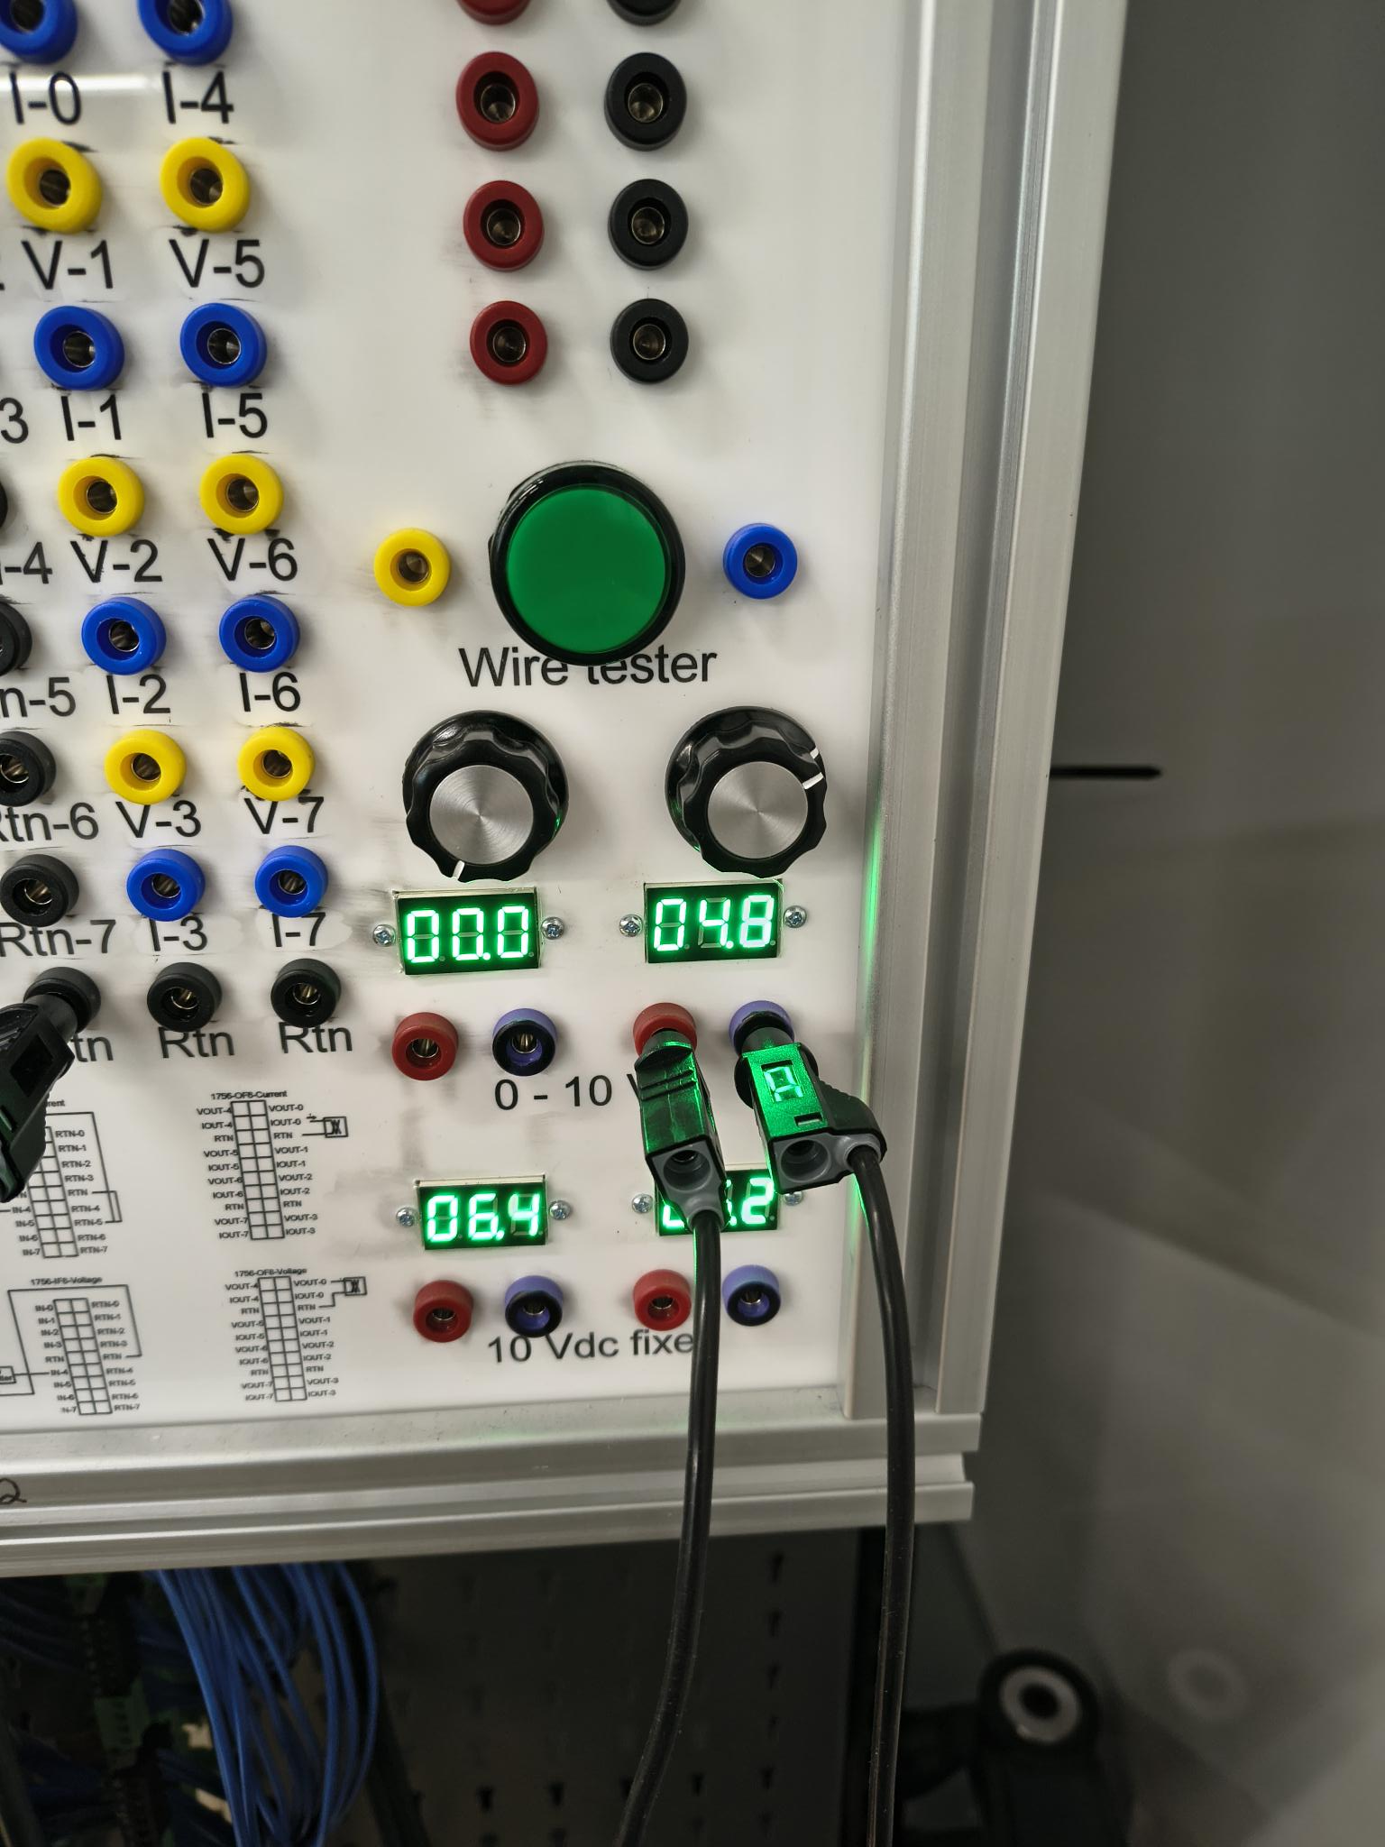
Figure 12 – Lab trainer panel: PLC/HMI enclosure with the 0–10 V wire-master voltage source wired to the analog input channel used for this lab

3. Results and Reflection

3.1 Link to theory
Produced/consumed tags set up a standing, cyclic connection between two controllers at project-download time, rather than sending data only when a MSG instruction executes. Once Station_214’s consumed tag is correctly matched to Station_212’s produced tag — same data type, same name, same connection parameters — EtherNet/IP maintains the link automatically and the consumer’s copy of the value updates every requested packet interval. This is why Station_214’s reading in Figure 11 lagged Station_212’s by one scan rather than being wrong: a cyclic connection trades a small, bounded delay for not needing any explicit communication logic in either program.
The analog scaling on Station_212, Local:3:I.Ch0Data / 32767 * 10, converts the module’s raw signed count (0–32767 for a 0–10 V unipolar range on a 1756-IF8) into volts, which is the standard way of turning a raw analog-in-channel value into an engineering unit for use elsewhere in a program or, as here, for sharing with another controller.

3.2 Errors and limitations
- Scaling is performed on the producer, not the consumer. The lab’s objective describes PLC 1 sending the raw analog value and PLC 2 converting it to a floating-point voltage. The screenshots show the opposite split: Station_212 both reads and scales the value (CPT, Figures 7–8) before producing the already-scaled Input_Voltage tag, while Station_214 only moves that value into Input_Voltage_212 with no scaling of its own (Figure 9–11). The inter-PLC transfer and the final voltage reading are both demonstrated correctly, but the scaling step is on the wrong side of the link if the assignment is graded on where exactly the conversion happens — worth confirming with the instructor or re-doing if the raw-value transfer is a specific mark on the rubric.
- Controller name mismatch. In the RSWho tree (Figure 3), the controller at 10.116.254.214 identifies itself as “Station_59” at the module level, while the backplane and every other screenshot refer to it as Station_214. This is almost certainly a left-over internal controller name from before the project was renamed, and did not affect communication, but it is worth renaming so the two don’t disagree on a resubmission.
- No screenshot of the consumed-tag dialog itself. Figure 6 documents the produced tag’s New Tag dialog on Station_212, but there is no equivalent capture of the New Tag dialog on Station_214 showing Type = Consumed, the producer controller name, and the remote (produced) tag name. The working MOV in Figures 10–11 proves the consumed tag exists and is correctly linked, but a grader may want that configuration screen specifically — consider adding it.
- One-scan lag reads as a mismatch if not explained. Figure 11’s two values (4.2280345 V vs 4.1920223 V) could look like an error rather than expected behaviour unless the report calls out that the two screenshots were taken moments apart while the input was actively changing.

3.3 Possible improvements
- Move the scaling (CPT / raw-to-voltage formula) into Station_214 and have Station_212 produce only the raw Local:3:I.Ch0Data count, to match the lab’s stated architecture exactly.
- Capture Station_214’s New Tag dialog for the consumed tag alongside Figure 6, for a complete tag-configuration record on both ends.
- Capture both controllers’ screens at the same instant (e.g. two monitors or a synchronized screenshot) when demonstrating real-time tracking, so the lag in Figure 11 is clearly a timing artifact and not an error.
- Rename the Station_214 controller consistently (the “Station_59” label in RSWho) before final submission.
- Complete the bonus tasks if time allows: a simulated overvoltage alarm on Station_214, and a second produced/consumed pair sending a status bit back to Station_212.

